Project Design Phase-II
Technology Stack (Architecture & Stack)

Date | 30 September 2026
Team ID | SWTID-2026-6284
Project Name | AI WEATHER WISE API
Maximum Marks | 4 Marks

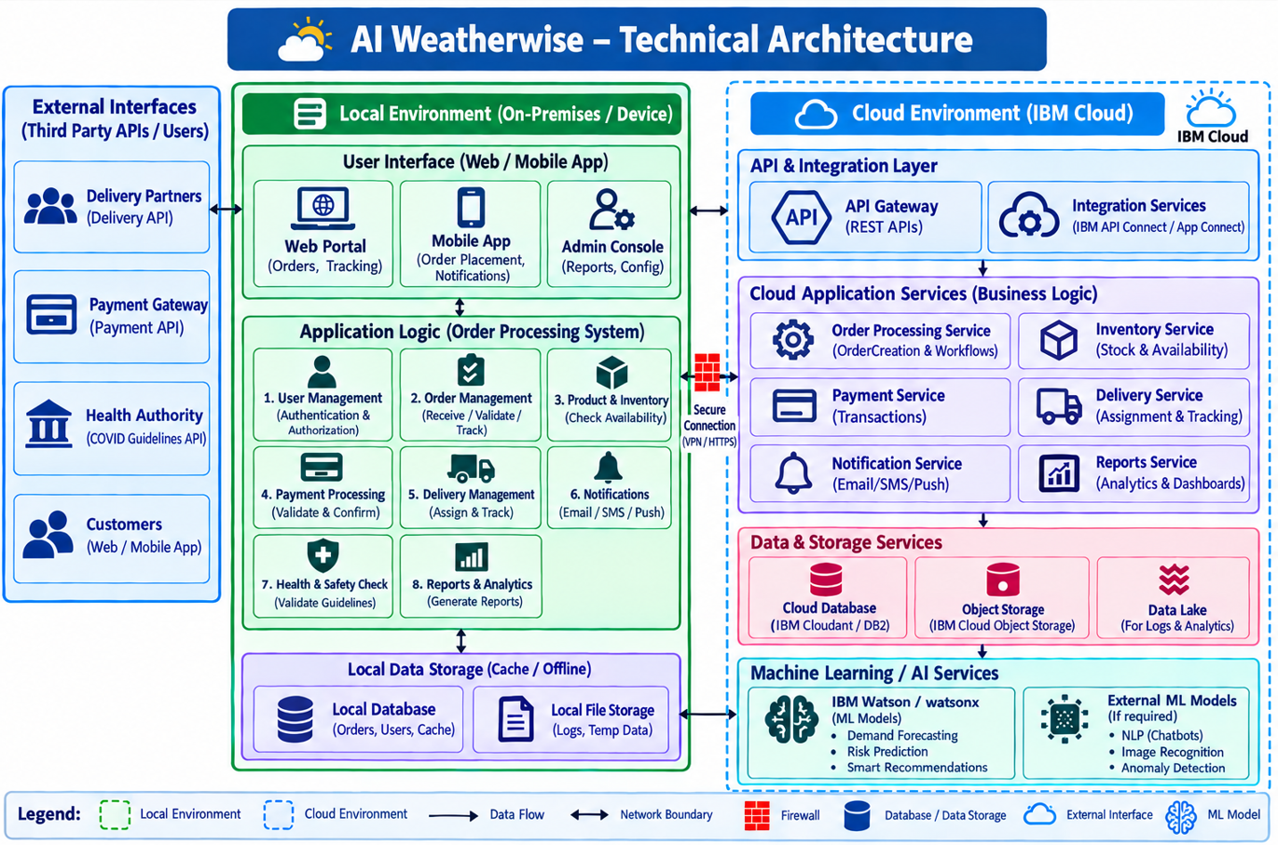
- Table-1: Components & Technologies:

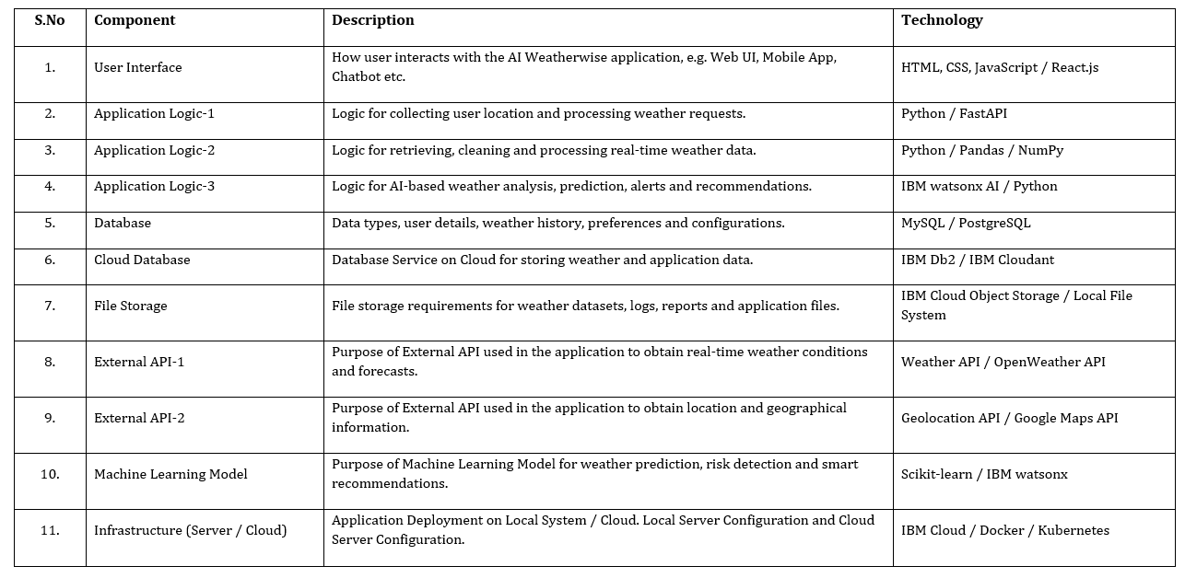

- Table-2: Application Characteristics:
